**Домашнее задание 2. Вариант 165. Дискретная математика.**

Группа P3116, Билошицкий Михаил Владимирович, ИСУ 367101.

Исходный граф:

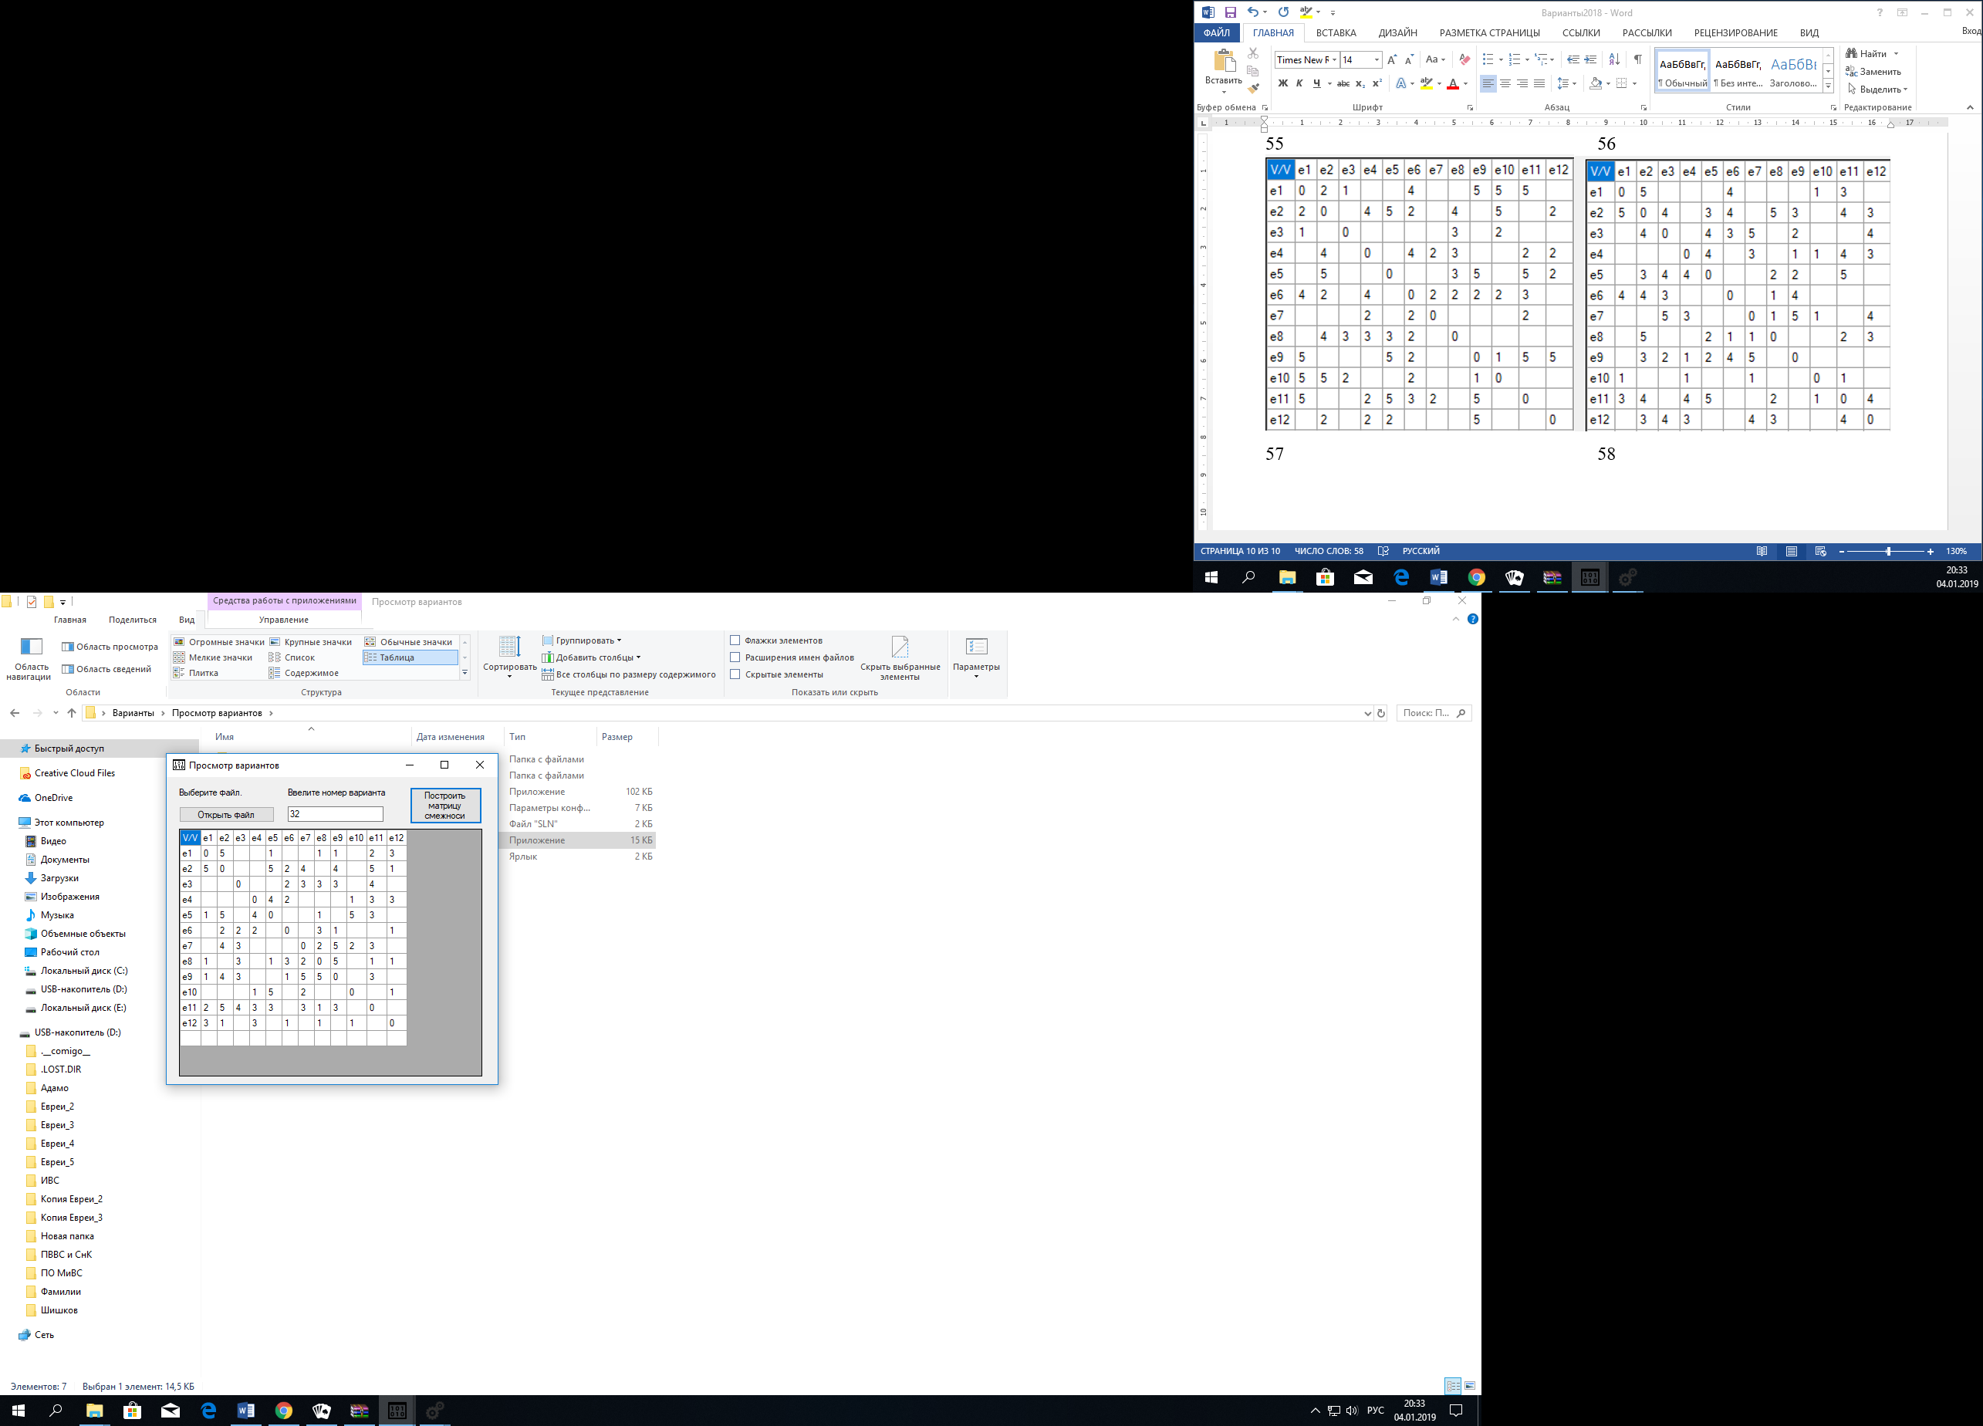

|  |  |  |  |  |  |  |  |  |  |  |  |  |
| --- | --- | --- | --- | --- | --- | --- | --- | --- | --- | --- | --- | --- |
| V/V | e1 | e2 | e3 | e4 | e5 | e6 | e7 | e8 | e9 | e10 | e11 | e12 |
| e1 | 0 | 5 |  |  | 1 |  |  | 1 | 1 |  | 2 | 3 |
| e2 | 5 | 0 |  |  | 5 | 2 | 4 |  | 4 |  | 5 | 1 |
| e3 |  |  | 0 |  |  | 2 | 3 | 3 | 3 |  | 4 |  |
| e4 |  |  |  | 0 | 4 | 2 |  |  |  | 1 | 3 | 3 |
| e5 | 1 | 5 |  | 4 | 0 |  |  | 1 |  | 5 | 3 |  |
| e6 |  | 2 | 2 | 2 |  | 0 |  | 3 | 1 |  |  | 1 |
| e7 |  | 4 | 3 |  |  |  | 0 | 2 | 5 | 2 | 3 |  |
| e8 | 1 |  | 3 |  | 1 | 3 | 2 | 0 | 5 |  | 1 | 1 |
| e9 | 1 | 4 | 3 |  |  | 1 | 5 | 5 | 0 |  | 3 |  |
| e10 |  |  |  | 1 | 5 |  | 2 |  |  | 0 |  | 1 |
| e11 | 2 | 5 | 4 | 3 | 3 |  | 3 | 1 | 3 |  | 0 |  |
| e12 | 3 | 1 |  | 3 |  | 1 |  | 1 |  | 1 |  | 0 |

Найти кратчайшие пути от начальной вершины e1 ко всем вершинам

Воспользуемся алгоритмом Дейкстры.

1. l(e1) = 0+

l(ei) = $∞$, i != 1

p = e1

|  |  |
| --- | --- |
| V/V | 1 |
| e1 | 0+ |
| e2 | $$∞$$ |
| e3 | $$∞$$ |
| e4 | $$∞$$ |
| e5 | $$∞$$ |
| e6 | $$∞$$ |
| e7 | $$∞$$ |
| e8 | $$∞$$ |
| e9 | $$∞$$ |
| e10 | $$∞$$ |
| e11 | $$∞$$ |
| e12 | $$∞$$ |

1. Временные метки = {e2, e5, e8, e9, e11, e12}

l(2) = min[$∞$, 0 + 5] = 5

l(5) = min[$∞$, 0 + 1] = 1

l(8) = min[$∞$, 0 + 1] = 1

l(9) = min[$∞$, 0 + 1] = 1

l(11) = min[$∞$, 0 + 2] = 2

l(12) = min[$∞$, 0 + 3] = 3

1. Устанавливаем постоянную пометку на e5.

|  |  |  |
| --- | --- | --- |
| V/V | 1 | 2 |
| e1 | 0+ |  |
| e2 | $$∞$$ | 5 |
| e3 | $$∞$$ | $$∞$$ |
| e4 | $$∞$$ | $$∞$$ |
| e5 | $$∞$$ | 1+ |
| e6 | $$∞$$ | $$∞$$ |
| e7 | $$∞$$ | $$∞$$ |
| e8 | $$∞$$ | 1 |
| e9 | $$∞$$ | 1 |
| e10 | $$∞$$ | $$∞$$ |
| e11 | $$∞$$ | 2 |
| e12 | $$∞$$ | 3 |

1. Временные метки = {e2, e4, e8, e10, e11}

l(2) = min(5, 1 + 5) = 5

l(4) = min($∞$, 1 + 4) = 5

l(8) = min(1, 1 + 1) = 1

l(10) = min($∞$, 1 + 5) = 6

l(11) = min(2, 1 + 3) = 2

1. Устанавливаем постоянную метку на e8.

|  |  |  |  |
| --- | --- | --- | --- |
| V/V | 1 | 2 | 3 |
| e1 | 0+ |  |  |
| e2 | $$∞$$ | 5 | 5 |
| e3 | $$∞$$ | $$∞$$ | $$∞$$ |
| e4 | $$∞$$ | $$∞$$ | 5 |
| e5 | $$∞$$ | 1+ |  |
| e6 | $$∞$$ | $$∞$$ | $$∞$$ |
| e7 | $$∞$$ | $$∞$$ | $$∞$$ |
| e8 | $$∞$$ | 1 | 1+ |
| e9 | $$∞$$ | 1 | 1 |
| e10 | $$∞$$ | $$∞$$ | 6 |
| e11 | $$∞$$ | 2 | 2 |
| e12 | $$∞$$ | 3 | 3 |

1. Временные метки = {e3, e6, e7, e9, e11, e12}

l(3) = min($∞$, 1 + 3) = 4

l(6) = min($∞$, 1 + 3) = 4

l(7) = min($∞$, 1 + 2) = 3

l(9) = min(1, 1 + 5) = 1

l(11) = min(2, 1 + 1) = 2

l(12) = min(3, 1 + 1) = 2

1. Устанавливаем постоянную метку на e9.

|  |  |  |  |  |
| --- | --- | --- | --- | --- |
| V/V | 1 | 2 | 3 | 4 |
| e1 | 0+ |  |  |  |
| e2 | $$∞$$ | 5 | 5 | 5 |
| e3 | $$∞$$ | $$∞$$ | $$∞$$ | 3 |
| e4 | $$∞$$ | $$∞$$ | 5 | 5 |
| e5 | $$∞$$ | 1+ |  |  |
| e6 | $$∞$$ | $$∞$$ | $$∞$$ | 4 |
| e7 | $$∞$$ | $$∞$$ | $$∞$$ | 3 |
| e8 | $$∞$$ | 1 | 1+ |  |
| e9 | $$∞$$ | 1 | 1 | 1+ |
| e10 | $$∞$$ | $$∞$$ | 6 | 6 |
| e11 | $$∞$$ | 2 | 2 | 2 |
| e12 | $$∞$$ | 3 | 3 | 2 |

1. Временные метки = {e2, e3, e6, e7, e11}

l(2) = min (5, 1 + 4) = 5

l(3) = min(4, 1 + 3) = 4

l(6) = min(4, 1 + 1) = 2

l(7) = min(3, 1 + 5) = 3

l(11) = min(2, 1 + 3) = 2

1. Устанавливаем постоянную метку на e6.

|  |  |  |  |  |  |
| --- | --- | --- | --- | --- | --- |
| V/V | 1 | 2 | 3 | 4 | 5 |
| e1 | 0+ |  |  |  |  |
| e2 | $$∞$$ | 5 | 5 | 5 | 5 |
| e3 | $$∞$$ | $$∞$$ | $$∞$$ | 3 | 4 |
| e4 | $$∞$$ | $$∞$$ | 5 | 5 | 5 |
| e5 | $$∞$$ | 1+ |  |  |  |
| e6 | $$∞$$ | $$∞$$ | $$∞$$ | 4 | 2+ |
| e7 | $$∞$$ | $$∞$$ | $$∞$$ | 3 | 3 |
| e8 | $$∞$$ | 1 | 1+ |  |  |
| e9 | $$∞$$ | 1 | 1 | 1+ |  |
| e10 | $$∞$$ | $$∞$$ | 6 | 6 | 6 |
| e11 | $$∞$$ | 2 | 2 | 2 | 2 |
| e12 | $$∞$$ | 3 | 3 | 2 | 2 |

1. Временные метки = {e2, e3, e4, e12}

l(2) = min(5, 2 + 2) = 4

l(3) = min(4, 2 + 2) = 4

l(4) = min(5, 2 + 2) = 4

l(12) = min(2, 2 + 1) = 2

1. Устанавливаем постоянную метку на e11.

|  |  |  |  |  |  |  |
| --- | --- | --- | --- | --- | --- | --- |
| V/V | 1 | 2 | 3 | 4 | 5 | 6 |
| e1 | 0+ |  |  |  |  |  |
| e2 | $$∞$$ | 5 | 5 | 5 | 5 | 4 |
| e3 | $$∞$$ | $$∞$$ | $$∞$$ | 3 | 4 | 4 |
| e4 | $$∞$$ | $$∞$$ | 5 | 5 | 5 | 4 |
| e5 | $$∞$$ | 1+ |  |  |  |  |
| e6 | $$∞$$ | $$∞$$ | $$∞$$ | 4 | 2+ |  |
| e7 | $$∞$$ | $$∞$$ | $$∞$$ | 3 | 3 | 3 |
| e8 | $$∞$$ | 1 | 1+ |  |  |  |
| e9 | $$∞$$ | 1 | 1 | 1+ |  |  |
| e10 | $$∞$$ | $$∞$$ | 6 | 6 | 6 | 6 |
| e11 | $$∞$$ | 2 | 2 | 2 | 2 | 2+ |
| e12 | $$∞$$ | 3 | 3 | 2 | 2 | 2 |

1. Временные метки = {e2, e3, e4, e7}

l(2) = min(4, 2 + 5) = 4

l(3) = min(4, 2 + 4) = 4

l(4) = min(4, 2 + 3) = 4

l(7) = min(3, 2 + 3) = 3

1. Устанавливаем постоянную метку на e12.

|  |  |  |  |  |  |  |  |
| --- | --- | --- | --- | --- | --- | --- | --- |
| V/V | 1 | 2 | 3 | 4 | 5 | 6 | 7 |
| e1 | 0+ |  |  |  |  |  |  |
| e2 | $$∞$$ | 5 | 5 | 5 | 5 | 4 | 4 |
| e3 | $$∞$$ | $$∞$$ | $$∞$$ | 3 | 4 | 4 | 4 |
| e4 | $$∞$$ | $$∞$$ | 5 | 5 | 5 | 4 | 4 |
| e5 | $$∞$$ | 1+ |  |  |  |  |  |
| e6 | $$∞$$ | $$∞$$ | $$∞$$ | 4 | 2+ |  |  |
| e7 | $$∞$$ | $$∞$$ | $$∞$$ | 3 | 3 | 3 | 3 |
| e8 | $$∞$$ | 1 | 1+ |  |  |  |  |
| e9 | $$∞$$ | 1 | 1 | 1+ |  |  |  |
| e10 | $$∞$$ | $$∞$$ | 6 | 6 | 6 | 6 | 6 |
| e11 | $$∞$$ | 2 | 2 | 2 | 2 | 2+ |  |
| e12 | $$∞$$ | 3 | 3 | 2 | 2 | 2 | 2+ |

1. Временные метки = {e2, e4, e10}

l(2) = min(4, 2 + 1) = 3

l(4) = min(4, 2 + 3) = 4

l(10) = min(6, 2 + 1) = 3

1. Устанавливаем постоянную метку на e2

|  |  |  |  |  |  |  |  |  |
| --- | --- | --- | --- | --- | --- | --- | --- | --- |
| V/V | 1 | 2 | 3 | 4 | 5 | 6 | 7 | 8 |
| e1 | 0+ |  |  |  |  |  |  |  |
| e2 | $$∞$$ | 5 | 5 | 5 | 5 | 4 | 4 | 3+ |
| e3 | $$∞$$ | $$∞$$ | $$∞$$ | 3 | 4 | 4 | 4 | 4 |
| e4 | $$∞$$ | $$∞$$ | 5 | 5 | 5 | 4 | 4 | 4 |
| e5 | $$∞$$ | 1+ |  |  |  |  |  |  |
| e6 | $$∞$$ | $$∞$$ | $$∞$$ | 4 | 2+ |  |  |  |
| e7 | $$∞$$ | $$∞$$ | $$∞$$ | 3 | 3 | 3 | 3 | 3 |
| e8 | $$∞$$ | 1 | 1+ |  |  |  |  |  |
| e9 | $$∞$$ | 1 | 1 | 1+ |  |  |  |  |
| e10 | $$∞$$ | $$∞$$ | 6 | 6 | 6 | 6 | 6 | 3 |
| e11 | $$∞$$ | 2 | 2 | 2 | 2 | 2+ |  |  |
| e12 | $$∞$$ | 3 | 3 | 2 | 2 | 2 | 2+ |  |

1. Временные метки = {e7}

l(7) = min(3, 3 + 4) = 3

1. Устанавливаем постоянную метку на e7.

|  |  |  |  |  |  |  |  |  |  |
| --- | --- | --- | --- | --- | --- | --- | --- | --- | --- |
| V/V | 1 | 2 | 3 | 4 | 5 | 6 | 7 | 8 | 9 |
| e1 | 0+ |  |  |  |  |  |  |  |  |
| e2 | $$∞$$ | 5 | 5 | 5 | 5 | 4 | 4 | 3+ |  |
| e3 | $$∞$$ | $$∞$$ | $$∞$$ | 3 | 4 | 4 | 4 | 4 | 4 |
| e4 | $$∞$$ | $$∞$$ | 5 | 5 | 5 | 4 | 4 | 4 | 4 |
| e5 | $$∞$$ | 1+ |  |  |  |  |  |  |  |
| e6 | $$∞$$ | $$∞$$ | $$∞$$ | 4 | 2+ |  |  |  |  |
| e7 | $$∞$$ | $$∞$$ | $$∞$$ | 3 | 3 | 3 | 3 | 3 | 3+ |
| e8 | $$∞$$ | 1 | 1+ |  |  |  |  |  |  |
| e9 | $$∞$$ | 1 | 1 | 1+ |  |  |  |  |  |
| e10 | $$∞$$ | $$∞$$ | 6 | 6 | 6 | 6 | 6 | 3 | 3 |
| e11 | $$∞$$ | 2 | 2 | 2 | 2 | 2+ |  |  |  |
| e12 | $$∞$$ | 3 | 3 | 2 | 2 | 2 | 2+ |  |  |

1. Временные метки = {e3, e10}

l(3) = min(4, 3 + 3) = 4

l(10) = min(3, 3 + 2) = 3

1. Устанавливаем постоянную метку на e10.

|  |  |  |  |  |  |  |  |  |  |  |
| --- | --- | --- | --- | --- | --- | --- | --- | --- | --- | --- |
| V/V | 1 | 2 | 3 | 4 | 5 | 6 | 7 | 8 | 9 | 10 |
| e1 | 0+ |  |  |  |  |  |  |  |  |  |
| e2 | $$∞$$ | 5 | 5 | 5 | 5 | 4 | 4 | 3+ |  |  |
| e3 | $$∞$$ | $$∞$$ | $$∞$$ | 3 | 4 | 4 | 4 | 4 | 4 | 4 |
| e4 | $$∞$$ | $$∞$$ | 5 | 5 | 5 | 4 | 4 | 4 | 4 | 4 |
| e5 | $$∞$$ | 1+ |  |  |  |  |  |  |  |  |
| e6 | $$∞$$ | $$∞$$ | $$∞$$ | 4 | 2+ |  |  |  |  |  |
| e7 | $$∞$$ | $$∞$$ | $$∞$$ | 3 | 3 | 3 | 3 | 3 | 3+ |  |
| e8 | $$∞$$ | 1 | 1+ |  |  |  |  |  |  |  |
| e9 | $$∞$$ | 1 | 1 | 1+ |  |  |  |  |  |  |
| e10 | $$∞$$ | $$∞$$ | 6 | 6 | 6 | 6 | 6 | 3 | 3 | 3+ |
| e11 | $$∞$$ | 2 | 2 | 2 | 2 | 2+ |  |  |  |  |
| e12 | $$∞$$ | 3 | 3 | 2 | 2 | 2 | 2+ |  |  |  |

1. Временные метки = {4}

l(4) = min(4, 3 + 1) = 4

1. Устанавливаем постоянную метку на e3.

|  |  |  |  |  |  |  |  |  |  |  |  |
| --- | --- | --- | --- | --- | --- | --- | --- | --- | --- | --- | --- |
| V/V | 1 | 2 | 3 | 4 | 5 | 6 | 7 | 8 | 9 | 10 | 11 |
| e1 | 0+ |  |  |  |  |  |  |  |  |  |  |
| e2 | $$∞$$ | 5 | 5 | 5 | 5 | 4 | 4 | 3+ |  |  |  |
| e3 | $$∞$$ | $$∞$$ | $$∞$$ | 3 | 4 | 4 | 4 | 4 | 4 | 4 | 4+ |
| e4 | $$∞$$ | $$∞$$ | 5 | 5 | 5 | 4 | 4 | 4 | 4 | 4 | 4 |
| e5 | $$∞$$ | 1+ |  |  |  |  |  |  |  |  |  |
| e6 | $$∞$$ | $$∞$$ | $$∞$$ | 4 | 2+ |  |  |  |  |  |  |
| e7 | $$∞$$ | $$∞$$ | $$∞$$ | 3 | 3 | 3 | 3 | 3 | 3+ |  |  |
| e8 | $$∞$$ | 1 | 1+ |  |  |  |  |  |  |  |  |
| e9 | $$∞$$ | 1 | 1 | 1+ |  |  |  |  |  |  |  |
| e10 | $$∞$$ | $$∞$$ | 6 | 6 | 6 | 6 | 6 | 3 | 3 | 3+ |  |
| e11 | $$∞$$ | 2 | 2 | 2 | 2 | 2+ |  |  |  |  |  |
| e12 | $$∞$$ | 3 | 3 | 2 | 2 | 2 | 2+ |  |  |  |  |

1. Устанавливаем постоянную метку на e4.

|  |  |  |  |  |  |  |  |  |  |  |  |  |
| --- | --- | --- | --- | --- | --- | --- | --- | --- | --- | --- | --- | --- |
| V/V | 1 | 2 | 3 | 4 | 5 | 6 | 7 | 8 | 9 | 10 | 11 | 12 |
| e1 | 0+ |  |  |  |  |  |  |  |  |  |  |  |
| e2 | $$∞$$ | 5 | 5 | 5 | 5 | 4 | 4 | 3+ |  |  |  |  |
| e3 | $$∞$$ | $$∞$$ | $$∞$$ | 3 | 4 | 4 | 4 | 4 | 4 | 4 | 4+ |  |
| e4 | $$∞$$ | $$∞$$ | 5 | 5 | 5 | 4 | 4 | 4 | 4 | 4 | 4 | 4+ |
| e5 | $$∞$$ | 1+ |  |  |  |  |  |  |  |  |  |  |
| e6 | $$∞$$ | $$∞$$ | $$∞$$ | 4 | 2+ |  |  |  |  |  |  |  |
| e7 | $$∞$$ | $$∞$$ | $$∞$$ | 3 | 3 | 3 | 3 | 3 | 3+ |  |  |  |
| e8 | $$∞$$ | 1 | 1+ |  |  |  |  |  |  |  |  |  |
| e9 | $$∞$$ | 1 | 1 | 1+ |  |  |  |  |  |  |  |  |
| e10 | $$∞$$ | $$∞$$ | 6 | 6 | 6 | 6 | 6 | 3 | 3 | 3+ |  |  |
| e11 | $$∞$$ | 2 | 2 | 2 | 2 | 2+ |  |  |  |  |  |  |
| e12 | $$∞$$ | 3 | 3 | 2 | 2 | 2 | 2+ |  |  |  |  |  |

**Результат кратчайших путей от вершины e1 до каждой из других вершин:**

|  |  |
| --- | --- |
| **e1** | **0+** |
| **e2** | **3+** |
| **e3** | **4+** |
| **e4** | **4+** |
| **e5** | **1+** |
| **e6** | **2+** |
| **e7** | **3+** |
| **e8** | **1+** |
| **e9** | **1+** |
| **e10** | **3+** |
| **e11** | **2+** |
| **e12** | **2+** |